URL: <http://www.cdnord.com/>

Clinique du Nord is a private clinic with luxurious air-conditioned rooms, attached bathrooms and toilets, and with television and VCR. It is situated on a white sand beach, with an individualised patio overlooking the bay.

We offer treatment in all fields of medicine and surgery, on a 24 hour basis.

**Services:**

* General Medicine
* Dermatology
* Surgery
* Psychiatry
* Paediatrics
* Opthalmology
* Gynaecology
* Physiotherapy
* Obstetrics
* Hydrotherapy

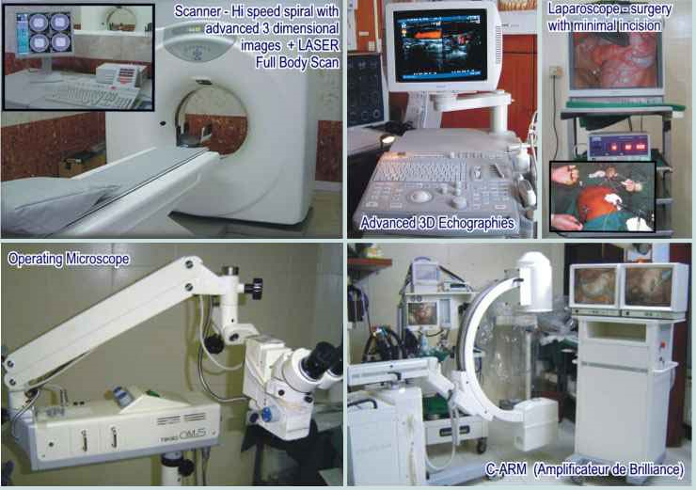

**Contact us:**

Royal Road, Tombeau Bay, Mauritius

Tel: +230 2472532; 2471056; 2475290

Fax: +230 2471254

